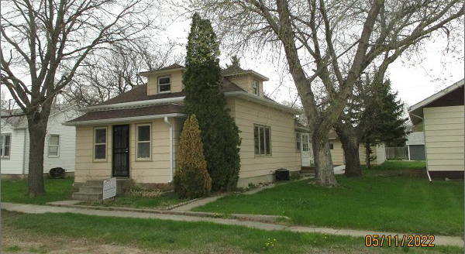
$40,000.00
THORSTENSON – RUTZ
5403 MAIN ST. SELBY
SELBY MILW LAND CO’S 1ST ADDN LOT 8 BLOCK 23
RECORD #4323

LOT SIZE 50’ X 140’ MAIN FLOOR 876 SQ FT
SINGLE FAMILY – 1 STORY/ATTIC TOTAL LIVING 1079 SQ FT
FAIR QUALITY – WORN CONDITION 3 BEDROOMS 1 BATH
BUILT IN 1910 BSMT – FURNACE ROOM ONLY
2015; ROOF FAIR, SIDING FAIR SOLID WALL PORCH 112 SQ FT
NATURAL GAS – CENTRAL AIR WOOD DECK 252 SQ FT
SIDING/ROOF GOOD ON GARAGE DET. GAR.504 SQ FT
SOLD ON 12/27/21 FOR $40,000
ASSESSED IN 2021 AT $23,620
SOLD ON 11/14/13 FOR $24,891
ASSESSED IN 2016 AT $21,890 RECORD #4323

