$20,000.00
PERKINS – MCGINNIS
7201 MINNEAPOLIS ST. JAVA
JAVA MILW LAND CO’S 1ST ADDN LOT 1 & N ½ LOT 2
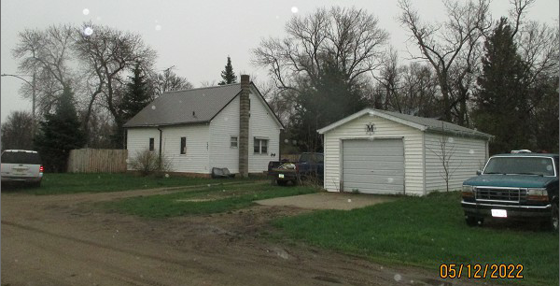
RECORD #4035

LOT SIZE 75’ X 140’ GROUND FLOOR 720 SQ FT
SINGLE FAMILY – 1 STORY/ATTIC TOTAL LIVING 900 SQ FT
WORN CONDITION 1 BATH
AVERAGE QUALITY WOOD DECK 187 SQ FT
BUILT IN 1920 DET. GARAGE 338 SQ FT
2013; ADDED METAL ROOF
1988; VINYL SIDING
SOLD ON 8/19/2021 FOR $20,000
ASSESSED IN 2021 AT $12,080
SOLD ON9/23/2019 FOR $10,000
ASSESSED IN 2016 AT $7,245 RECORD #4035

