$300,000.00
SACKREITER DEVELOPMENT LLC – ROCK RESOURCES LLC
920 6TH AVE WEST, MOBRIDGE
MOBRIDGE NWT’S CO’S 3RD ADDN LOTS 7,8 & 9 BLOCK 38
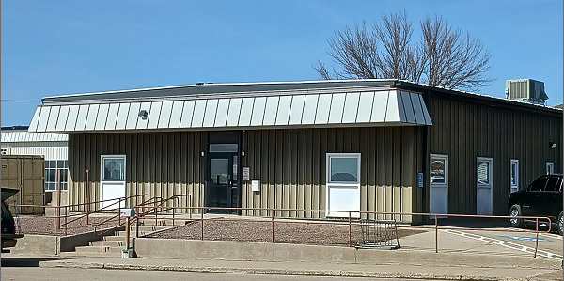
RECORD #6195

LOT SIZE 120’ X 150’ MAIN AREA 4160 SQ FT
100% OFFICE BUILDING 14 OFFICES ON EACH SIDE
ONE STORY 2 RESTROOMS
AVERAGE QUALITY & CONDITION HVAC HEATING
BUILT IN 1975 + -
SOLD ON 11/24/2021 FOR $300,000
ASSESSED IN 2021 AT $153,130
ASSESSED IN 2018 AT $163,015 RECORD #6195

