$105,000.00
PETERSON – MOUND
816 10TH AVE. WEST, MOBRIDGE
MOBRIDGE NWT’S CO’S 3RD ADDN LOT 10 BLOCK 31
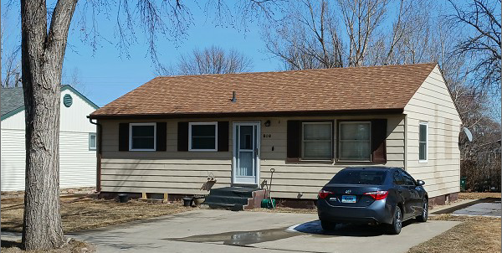
RECORD #6147

LOT SIZE 50’ X 120’ MAIN FLOOR 900 SQ FT
SINGLE FAMILY – ONE STORY 2 BEDROOMS ABOVE
AVERAGE QUALITY & CONDTION 2 BEDROOMS BELOW
BUILT IN 1955 1 ½ BATHS
2014; ROOF GOOD, SIDING FAIR BASEMENT 900 SQ FT
CENTRAL AIR - NATURAL GAS 800 SQ FT FINISHED
2010; 2 NEW EGRESS NORTH DET. GARAGE 624 SQ FT
2009; REMODELED KITCHEN OPEN SLAB 100 SQ FT
SOLD ON 11/29/21 FOR $105,000
ASSESSED IN 2021 AT $102,800
SOLD IN 2014 FOR $100,000
ASSESSED IN 2015 AT $100,600 RECORD # 6147

