$42,500.00
WULF – KRONE
1121 5TH AVE WEST, MOBRIDGE
MOBRIDGE NWTS CO’S 2ND ADDN LOT 1 BLOCK 19
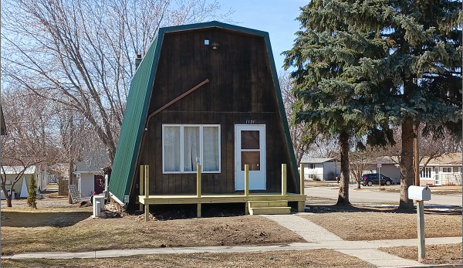
RECORD #6044

LOT SIZE 46’ X 140’ MAIN FLOOR 876 SQ FT
SINGLE FAMILY – 1 ½ STORY TOTAL LIVING 1284 SQ FT
AVERAGE CONDITION & QUALITY 3 BEDROOMS 1 ½ BATHS
BUILT IN 1980 BASEMENT 876 SQ FT
RECENT METAL ROOF & SIDING DET. GARAGE 480 SQ FT
2015; CENTRAL AIR, WINDOWS GOOD
RECENT WOOD DECKS FRONT & BACK
SOLD ON 11/30/2021 FOR $42,500
ASSESSED IN 2021 AT $61,910
SOLD ON 3/31/10 FOR $42,500
ASSESSED IN 2016 AT $59,790 RECORD #6044

