$79,000.00
BARZ – MARSHALL
916 1ST AVE. WEST, MOBRIDGE
MOBRIDGE MAIN PARK LOT 16 BLOCK 19
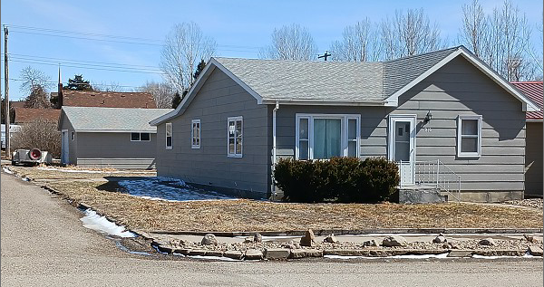
RECORD #5678

LOT SIZE 37.5’ X 142’ TOTAL LIVING 1268 SQ FT
ONE STORY – SINGLE FAMILY 2 BEDROOMS 1 ½ BATHS
AVERAGE QUALITY & CONDITION COVERED PORCH 128 SQ FT
BUILT IN 1920 DETACHED GARAGE 506 SQ FT
2014; SOME NEWER WINDOWS CRAWL SPACE
GARAGE TURNED INTO LIVING
NATURAL GAS – CENTRAL AIR
1990; 10’ X 22’ ADDN TO GARAGE
SOLD ON 12/13/2021 FOR $79,000
ASSESSED IN 2021 AT $50,290
SOLD ON 7/8/2019 FOR $43,500
ASSESSED IN 2016 AT $48,830 RECORD #5678

