$75,000.00
GIENGER – OXNER
520 WEST GRAND CROSSING, MOBRIDGE
MOBRIDGE GRAND CROSSING ADDN LOT 7 & 8 BLOCK 37
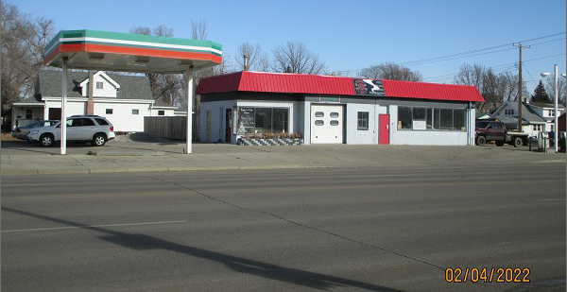
RECORD # 5289

LOT SIZE 51’ X 140’ TOTAL AREA 1460 SQ FT
100% COMMERCIAL MASONRY BEARING WALLS
SERVICE REPAIR GARAGE CANOPY 576 SQ FT
ONE STORY
AVERAGE QUALITY & CONDITION
BUILT IN 1953 + -
SOLD ON 10/18/2021 FOR $75,000
ASSESSED IN 2021 AT $56,890
SOLD ON 9/12/2007 FOR $50,000
ASSESSED IN 2016 AT $70,940 RECORD #5289

