$85,000.00
FEES – STICKNEY
519 5TH AVE EAST, MOBRIDGE
MOBRIDGE FAIRVIEW ADDN LOTS 1 THRU 3 BLOCK 28
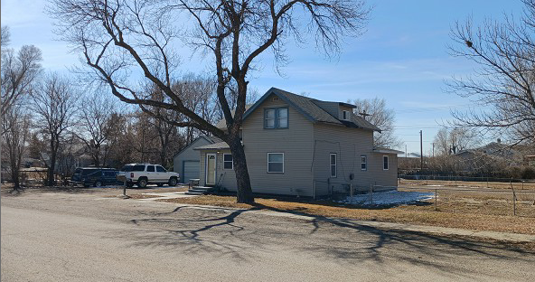
RECORD #5166

LOT SIZE 140’ X 140’ GROUND FLOOR 640 SQ FT
SINGLE FAMILY – 1 ½ STORY TOTAL LIVING 904 SQ FT
FAIR CONDITION & QUALITY 3 BEDROOMS 1 ½ BATHS
BUILT IN 1936 BASEMENT 528 SQ FT
2014; ROOF FAIR, VINYL SIDING DET. GARAGE 624 SQ FT
ALUMINUM WINDOWS SWP 84 SQ FT
CENTRAL AIR, WINDOW ABOVE OPEN SLAB 60 SQ FT
LARGE CRACK IN FOUNDATION
SOLD ON 10/14/21 FOR $85,000
ASSESSED IN 2021 AT $49,980
SOLD ON 9/17/2004 FOR $28,350
ASSESSED IN 2015 AT $45,750 RECORD #5166

