$23,000.00
MATT KELLER PROPERTIES – CLAYMORE
610 4TH AVE EAST, MOBRIDGE
MOBRIDGE FAIRVIEW ADDN LOTS 15 & 16 BLOCK 15
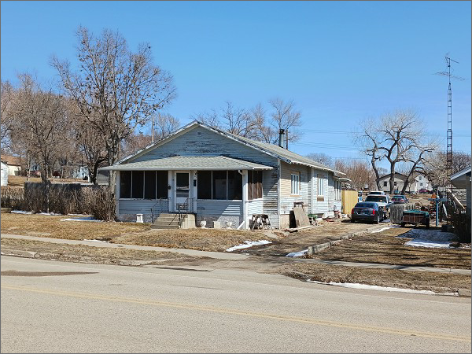
RECORD #5115

LOT SIZE75’ X 140’ MAIN LIVING 1436 SQ FT
SINGLE FAMILY – 1 STORY 4 BEDROOMS 1 BATH
BELOW NORMAL CONDITI0N KWP 352 SQ FT
FAIR QUALITY BASEMENT 1424 SQ FT
BUILT IN 1910
2014; NATURAL GAS
WALLS & CEILING REPLACED IN ONE ROOM
SOLD ON 12/29/2021 FOR $23,000
ASSESSED IN 2021 AT $23,320
SOLD ON 10/02/14 FOR $20,000
ASSESSED IN 2015 AT $21,590 RECORD #5115

