$95,005.00
HAUFSCHILD – BEYERS
602 4TH AVE EAST, MOBRIDGE
MOBRIDGE FAIRVIEW ADDN LOT 9 & S 17’ OF LOT 10 BLOCK 15
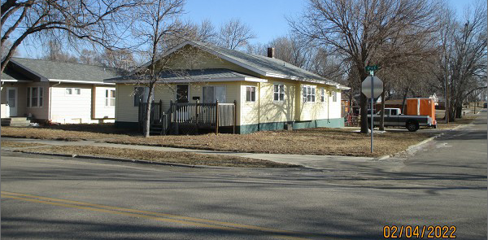
RECORD #5111

LOT SIZE 54.5’ X 140’ TOTAL LIVING 1476 SQ FT
SINGLE FAMILY – ONE STORY 3 BEDROOMS
AVERAGE QUALITY & CONDITION SOLID WALL PORCH 196 SQ FT
BUILT IN 1926 WOOD DECK 112 SQ FT
2014; PROPANE, SIDING POOR KNEE WALL PORCH 128 SQ FT
WOOD DECK SLIDING DOOR
NEWER VINYL CLAD WINDOWS
1994; ADDN TO KITCHEN & LAUNDRY ROOM
COMPLETE REWIRE OF ORIGINAL HOUSE
SOLD ON 10/22/21 FOR $95,005
ASSESSED IN 2021 AT $64,300
ASSESSED IN 2014 AT $55,380 RECORD #5111

