$545,000.00
WEBSTER – LARSON
2019 SCHIRBER DR. MOBRIDGE
SHIRBER’S 2ND ADDITION LOT 1, 13-124-80
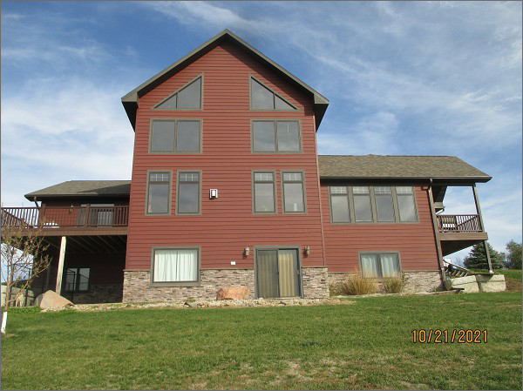
RECORD #7902
LOT SIZE 1.91 ACRES TOTAL SQ FT 2390
SINGLE FAMILY – 2 STORY FRAME 3 BEDROOMS 3 ½ BATHS
NORMAL CONDITION & QUALITY LOFT, WALKOUT BSMT.
ELECTRIC HEAT – CENTRAL AIR 2 STALL ATT. GARAGE
BUILT IN 2013 WOOD DECK 420 SQ FT
CHERRY WOOD FLOORS & CABINETS FINISHED BSMT 1000 SQ FT
GRANITE COUNTER TOPS
HEATED FLOORS IN BASEMENT, BATHROOM
SOLD ON 8/24/21 FOR $545,000
ASSESSED IN 2021 AT $371,590
SOLD ON 7/8/2017 FOR $560,000 CFD RECORD #7902
ASSESSED IN 2017 AT $307,235

