$239,000.00
SCHATZ – FLAHERTY
810 4TH AVE EAST, MOBRIDGE
MOBRIDGE SKYLINE ADDN LOTS 15 & 16 & THE S ½ OF VACATED 9TH ST. ADJ.TO LOT 15 BLOCK 1
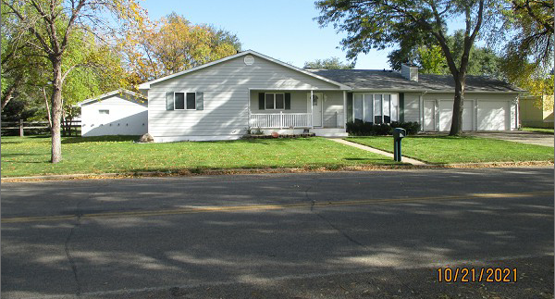
RECORD #6444

LOT SIZE 155’ X 140’ GROUND FLOOR 1640 SQ FT
1 STORY – SINGLE FAMILY BASEMENT 1640 SQ FT
AVERAGE QUALITY & CONDITION 600 SQ FT FIN. REC. IN BSMT.
BUILT IN 1965 3 BEDROOMS ABOVE 2 BELOW
2015; ROOF GOOD, WINDOWS GOOD 2 FULL BATHS ONE ¾ BATH
MASONITE SIDING GOOD, CENTRAL AIR TWO ½ BATHS
BLOCK FOUNDATION FAIR ATTACHED GARAGE 672 SQ FT
SOLD ON 9/15/2021 FOR $239,000 DET. GARAGE 1120 SQ FT
ASSESSED IN 2021 AT $192,500 ROOFED PORCH 316 SQ FT
SOLD ON 3/14/1996 FOR $85,000 OPEN SLAB PORCH 1100 SQ FT
ASSESSED IN 2015 AT $118,575 RECORD #6444

