$34,000.00
BWRE INVESTMENTS – MAHAR
SOUTH MAIN ST. MOBRIDGE
MOBRIDGE ORIGINAL PLAT LOTS 7, 8 & 9 BLOCK 10
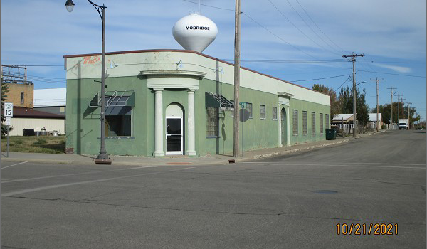
RECORD #6323

LOT SIZE 75’ X 140’ ONE STORY
STORAGE WAREHOUSE 5,100 TOTAL AREA
LOW QUALITY
AVERAGE CONDITION
BUILT IN 1925
SOLD ON 9/14/2021 FOR $34,000
ASSESSED IN 2021 AT $38,430
SOLD ON 3/22/2018 FOR $25,000 RECORD #6323
ASSESSED IN 2018 AT $38,430
ASSESSED IN 2015 AT $38,430

