$54,500.00
TB PROPERTIES – GORSUCH
MAIN ST. MOBRIDGE
MOBRIDGE ORIGINAL LOT 9 BLOCK 6
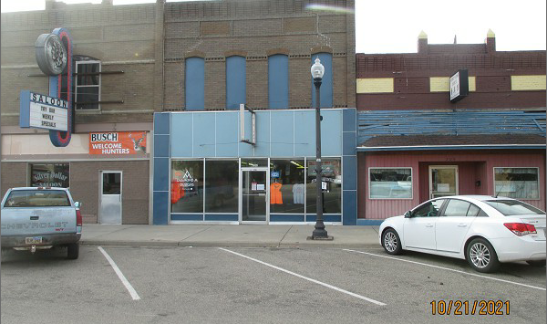
RECORD #6280

LOT SIZE 25’ X 140’ GROUND FLOOR 2900 SQ FT
100% RETAIL 2ND STORY 1550 SQ FT
AVERAGE QUALITY & CONDITION RESIDENCY UNITS ON 2ND
BUILT IN 1920’S
BRICK WALLS, GLASS & METAL FAÇADE
SOLD ON 8/24/2021 FOR $54,500
ASSESSED IN 2021 AT $42,555
SOLD ON 10/20/2020 FOR $$15,000 RECORD #6280
ASSESSED IN 2016 AT $42,555

