$95,000.00
ROTHSTEIN – VOJTA
4TH ST. WEST, MOBRIDGE
MOBRIDGE ORIGINAL LOT 18 BLOCK 3
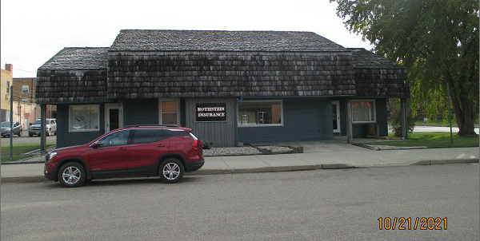
RECORD #6250

LOT SIZE 140’ X 50’ MAIN FLOOR 1712 SQ FT
SINGLE STORY BASEMENT 1676 SQ FT
100% OFFICE BUILDING BASEMENT UNFINISHED
BUILT IN 1970
AVERAGE QUALITY & CONDITION
SOLD ON 3/9/2021 FOR $95,000
ASSESSED IN 2021 AT $66,225
SOLD ON 9/3/2002 FOR $42,500
ASSESSED IN 2016 AT $66,225 RECORD #6250

