$155,000.00
MW TIRED LLC – HELM RENTALS LLC
314 MAIN ST. MOBRIDGE
MOBRIDGE ORIGINAL LOTS 13, 14 & S 1’ OF LOT 15 (AKA LOT 15) BLOCK 2
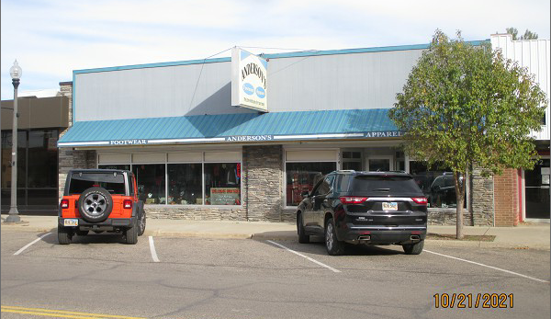
RECORD #6241

LOT SIZE 50’ X 140’ 6,900 SQ FT
100% RETAIL STORE PARTIAL CRAWL SPACE
ONE STORY PACKAGE UNIT
AVERAGE QUALITY & CONDITION STEAM HEAT
BUILT IN 1957 2000 REMODEL $2,500
SOLD ON 10/4/21 FOR $155,000 1986 REMODEL $3,000
ASSESSED IN 2021 AT $112,445
SOLD ON 7/30/20 FOR $109,000
SOLD ON 4/7/20 FOR $175,000
ASSESSED IN 2016 AT $112,445
ASSESSED IN 2012 AT $82,115 RECORD #6241

