$145,000.00
DARLING REVOCABLE – BEFFA
904 10TH AVE. MOBRIDGE
MOBRIDGE NWTS 3RD LOT 7 BLOCK 30
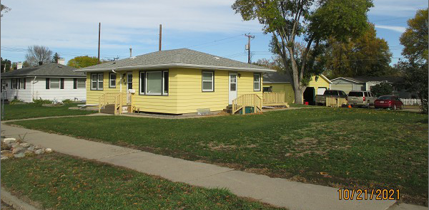
RECORD #6140

LOT SIZE 60’ X 120’ GROUND FLOOR 1136 SQ FT
SINGLE FAMILY – 1 STORY 2 BEDROOMS 1 ½ BATHS
AVERAGE QUALITY & CONDITION BASEMENT 910 SQ FT
BUILT IN 1960 BASEMENT FINISHED
2014; SHINGLES GOOD, SIDING FAIR DET. GARAGE 624 SQ FT
WOOD DECK WITH SLIDING GLASS WOOD DECK 140 SQ FT
CENTRAL AIR, 2’ EAVE OVERHANG
SOLD ON 10/5/21 FOR $145,000
ASSESSED IN 2021 AT $125,030
SOLD ON 12/5/2003 FOR $63,000
ASSESSED IN 2014 AT $79,005 RECORD #6140

