$263,000.00
WIENTJES – KELLER
1020 10TH ST WEST, MOBRIDGE
MOBRIDGE NWTS CO’S 3RD ADDN S 20’ OF LOT 4 & ALL LOTS 5 & 6 BLOCK 27
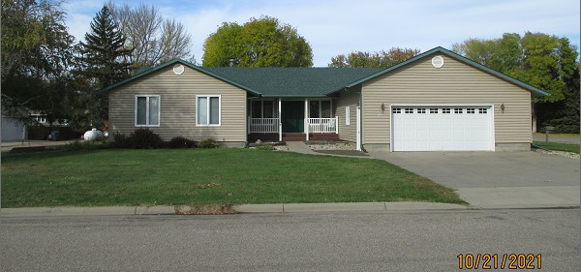
RECORD #6116

LOT SIZE 120’ X 120’ GROUND FLOOR 1776 SQ FT
SINGLE FAMILY – 1 STORY 3 BEDROOMS 3 ½ BATHS
AVERAGE QUALITY & CONDITION BASEMENT 1776 SQ FT
BUILT IN 1979 535 SQ FT FINISHED LIVING
2014; ROOF GOOD, VINYL SIDING ATT. GARAGE 728 SQ FT
WINDOWS FAIR, SPRINKLER SYSTEM ROOFED PORCH 126 SQ FT
CENTRAL AIR, BLOCK FOUNDATION WOOD DECK 168 SQ FT
2019; NEW STORAGE SHED 12’X18’
SOLD ON 9/22/21 FOR $263,000
ASSESSED IN 2021 AT $202,330
SOLD ON 6/21/2018 FOR $225,000
ASSESSED IN 2016 AT $$197,070 RECORD #6116

