$170,000.00
FLAHERTY – HAMMER
518 9TH ST WEST, MOBRIDGE
MOBRIDGE NWTS 1ST ADDN LOT 6 BLOCK 8
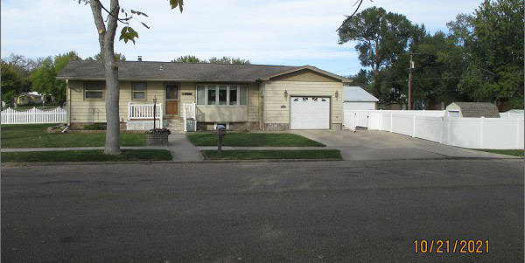
RECORD #5946

LOT SIZE 60’ X 140’ GROUND FLOOR 988 SQ FT
SINGLE FAMILY – 1 STORY BASEMENT 988 SQ FT
AVERAGE QUALITY & CONDITION 494 SQ FT LIVING IN BSMT
BUILT IN 1961 2 BEDROOMS 1 FULL BATH
CENTRAL AIR - NATURAL GAS ONE ¾ BATH ONE ½ BATH
2014; ROCK FACING ON BSMT-POURED ATT. GARAGE 320 SQ FT
BOW WINDOWS WITH GLASS BLOCK WINDOWS
ALUMINUM SIDING, 3 SEASON PORCH, METAL ROOF
SOLD ON 8/23/21 FOR $170,000
ASSESSED IN 2021 AT $110,420 5’ X 12’ UTILITY SHED
SOLD ON 10/17/19 FOR $155,000 8’ X 10’ UTILITY SHED
ASSESSED ON 2016 AT $106,800 RECORD #5946

