$114,000.00
M & C RENTALS – JOEL FARNHAM REVOCABLE TRUST ET AL
1012 1ST AVE WEST, MOBRIDGE
MOBRIDGE MAIN PARK N 25’ OF LOT 14 & S 25’ OF LOT 15 BLOCK 18
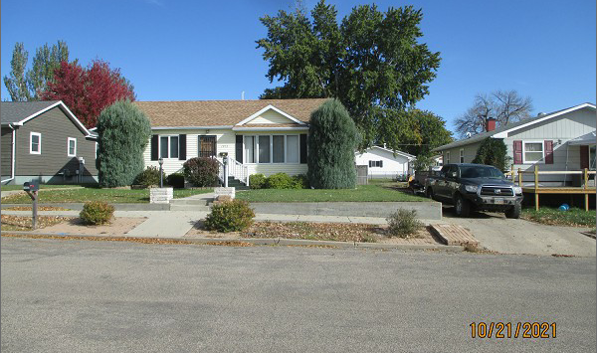
RECORD #5669

LOT SIZE 50’ X 142’ GROUND FLOOR 1280 SQ FT
SINGLE FAMILY – 1 STORY FINISHED BSMT. 864 SQ FT
AVERAGE QUALITY & CONDITION 2 BEDROOMS UP 2 DOWN
BUILT IN 1949 2 FULL BATHS
2014; ROOF GOOD, NEW WINDOWS DETACHED GARAGE 384 SQ FT
VINYL SIDING, NATURAL GAS, CENTRAL AIR
WRAP AROUND DECK SLIDING GLASS DOOR
FOUNDATION GOOD
SOLD ON 9/10/21 FOR $114,000 RECORD #5669
ASSESSED IN 2021 AT $95,500
SOLD ON 10/10/14 FOR $92,500, ASSESSED IN 2014 AT $70,345

