$155,000.00
SHELLEY – MIX/ALLEN
919 1ST AVE EAST, MOBRIDGE
MOBRIDGE MAIN PARK LOTS 1 & 2 BLOCK 14
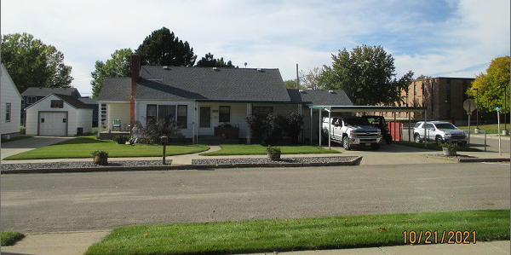
RECORD #5638

LOT SIZE 75’ X 142’ GROUND FLOOR 1634 SQ FT
SINGLE FAMILY – 1 STORY 3 BEDROOMS, 1 FULL BATH
AVERAGE QUALITY & CONDITION ONE ¾ BATH, ONE ½ BATH
BUILT IN 1945 BASEMENT 1634 SQ FT
2014; ROOF GOOD, CENTRAL AIR 2005 BATHROOM ADDN
NATURAL GAS, FOUNDATION GOOD ROOFED PORCH 120 SQ FT
SOLD ON 8/25/21 FOR $155,000 KNEE WALL PORCH 300 SQ FT
ASSESSED IN 2021 AT $115,210 DET. GARAGE 1150 SQ FT
SOLD ON 8/22/06 FOR $105,000 CARPORT 460 SQ FT
ASSESSED IN 2006 AT $57,913
SOLD ON 6/16/05 FOR $62,000 RECORD #5638

