$85,000.00
SILBERNAGEL – ORTLIEB
715 2ND AVE. EAST, MOBRIDGE
MOBRIDGE GRAND CROSSING ADDN. LOT 3 BLOCK 60
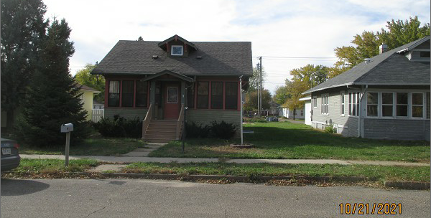
RECORD # 5462

LOT SIZE 50’ X 140’ GROUND FLOOR 1164 SQ FT
1 STORY – SINGLE FAMILY 3 BEDROOM 1 ½ BATHS
AVERAGE QUALITY & CONDITION 1164 SQ FT BASEMENT
BUILT IN 1930 3 SEASON PORCH 216 SQ FT
2014; LAP SIDING POOR, WINDOWS POOR FINISHED ATTIC
SIDING GOES ALL THE WAY TO GROUND NATURAL GAS
EGRESS NORTH, CENTRAL AIR OPEN ROOFED PORCH
SOLD ON 10/4/21 FOR $85,000
ASSESSED IN 2021 AT $64,060
SOLD ON 3/12/19 FOR $63,000 RECORD #5462
ASSESSED IN 2018 AT $62,900
SOLD ON 3/12/12 FOR $49,000
ASSESSED IN 2012 AT $55,725

