$92,565.00
KUMBAYA LLC – CONRAD
717 NORTH MAIN, MOBRIDGE
MOBRIDGE PARK-SIDE SUBD. OF LOTS 58 & 59 OF GRAND CROSSING 1ST ADDN LOTS 2 & 3 BLOCK 58
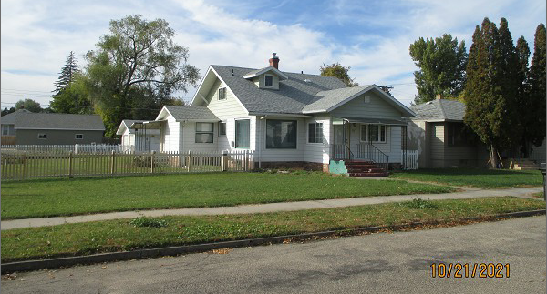
RECORD #5443

LOT SIZE 94’ X 152’ GROUND FLOOR 1320 SQ FT
1 ½ STORY – SINGLE FAMILY TOTAL AREA 1736 SQ FT
AVERAGE QUALITY & CONDITION BASEMENT 992 SQ FT
BUILT IN 1935 BSMT. HALF FINISHED
2014; VINYL SIDING, WINDOWS FAIR 2 BEDROOMS
ROOF GOOD, GARAGE SIDING – ROOF GOOD 1 FULL BATH
NATURAL GAS – CENTRAL AIR TWO HALF BATHS
SOLD ON 5/21/21 FOR $92,565 DET. GARAGE 624 SQ FT
ASSESSED IN 2021 AT $71,800 13’ X 14’ WOOD DECK
SOLD ON 3/14/12 FOR $57,000
ASSESSED IN 2016 AT $69,590 RECORD #5443

