$164,900.00
LANDIS – PRATT
707 1ST AVE WEST, MOBRIDGE
MOBRIDGE GRAND CROSSIN ADDN LOT 3 BLOCK 57
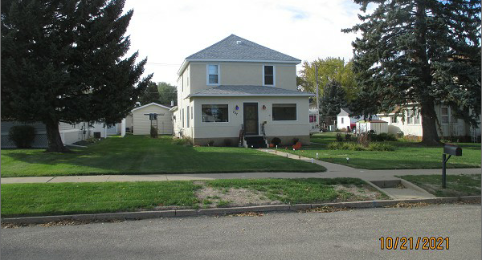
RECORD #5433

LOT SIZE 50’ X 140’ GROUND FLOOR 888 SQ FT
SINGLE FAMILY – 2 STORY TOTAL LIVING 1776 SQ FT
AVERAGE QUALITY & CONDITION BASEMENT 576 SQ FT
BUILT IN 1920 4 BEDROOMS ABOVE
2010; NEW 14’X24’ DET. GARAGE $9,500 1 ½ BATHS
2006; REMODEL BATHROOM $3,000 ATT. GARAGE 576 SQ FT
FRONT HALF STUCCO, BACK HALF MASONITE
SOLD ON 6/16/21 FOR $$164,900 SOLID WALL PORCH 168 SQ FT
ASSESSED IN 2021 AT $102,600
ASSESSED IN 2014 AT $74,375 RECORD #5433

