$118,000.00
GALAZKA – CASTILLO
520 3RD AVE WEST, MOBRIDGE
MOBRIDGE GRAND CROSSING ADDN LOT 17 BLOCK 39
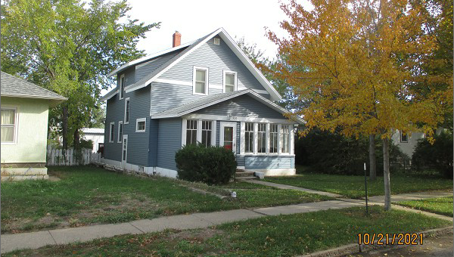
RECORD #5315

LOT SIZE 50’ X 140’ GROUND FLOOR 716 SQ FT
SINGLE FAMILY – 1 ½ STORY TOTAL LIVING 1231 SQ FT
AVERAGE QUALITY & CONDITION 2 BEDROOMS 1 ½ BATHS
BUILT IN 1940 + - BASEMENT 644 SQ FT
2012; NEW STEEL SIDING, NEW SHINGLES DET. GARAGE 280 SQ FT
2014; 3 SEASON PORCH FRONT SOLID WALL PORCH 70 SQ FT
NATURAL GAS, EXTERIOR STAIRCASE EAST KNEE WALL PORCH 189 SQ FT
SOLD ON 9/4/21 FOR $118,000 OPEN SLAB PORCH 84 SQ FT
ASSESSED IN 2021 AT $74,880
SOLD ON 9/5/18 FOR $87,500
ASSESSED IN 2016 AT $23,403 RECORD #5315

