$22,000.00
O’CONNOR ESTATE – FORD
607 7TH AVE EAST, MOBRIDGE
MOBRIDGE FAIRVIEW ADDN S 20.5’ OF LOT 5 & ALL LOT 6 BLOCK 17
1964 10’ X 47’ HICKS
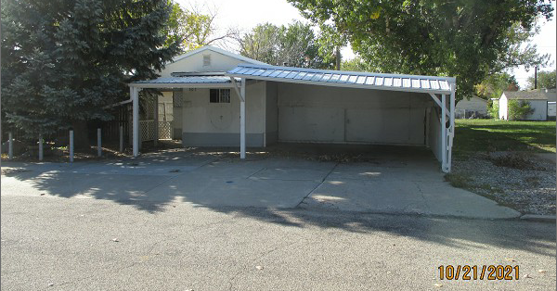
RECORD #5128

LOT SIZE 58’ X 140’ MAIN LIVING AREA 604 SQ FT
SINGLE FAMILY 2 BEDROOMS 1 ½ BATHS
MANUFACTURED HOME CARPORT 40’ X 18’
FAIR QUALITY AVERAGE CONDITION METAL SHED 10’ X 12’
BUILT IN 1964 METAL SHED 10’ X 10’
2015; METAL ROOF SOLID WALL PORCH 320 SQ FT
CARPORT METAL ROOF
SOLD ON 9/20/21 FOR $22,000
ASSESSED IN 2020 AT $21,350
ASSESSED IN 2017 AT $16,320 RECORD #5128

