$85,000.00
PETERS – OSGOOD
705 2ND ST EAST, MOBRIDGE
MOBRIDGE EKLO’S 3RD ADDN E 76’ OF W ½ OF LOTS 8B & 9 & W 10’ OF E ½ OF LOT 8B
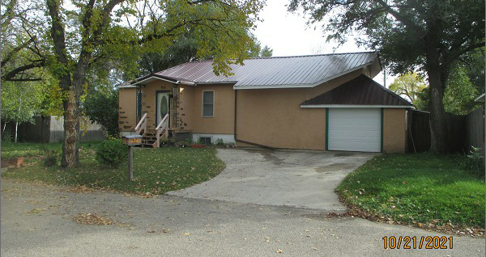
RECORD #4992

LOT SIZE 76’ X 159.2’ & 10’ X 19.4’ TOTAL LIVING 1284 SQ FT
SINGLE FAMILY – 1 STORY MAIN AREA 624 SQ FT
FAIR CONDITION – AVERAGE QUALITY BASEMENT 624 SQ FT
BUILT IN 1950 2 BEDROOMS 1 ¾ BATHS
2014; 3 SEASON PORCH ONLY GLASS SOUTH ATT. GARAGE 480 SQ FT
METAL ROOF, STUCCO
ALUMINUM/VINYL WINDOWS
SOLD ON 8/31/21 FOR $85,000
ASSESSED IN 2021 AT $30,170
ASSESSED IN 2016 AT $31,170
ASSESSED IN 2014 AT $22,070 RECORD #4992

