$45,000.00
STEIGER/GISI – EILERT/GASPAR
214 4TH AVE EAST, MOBRIDGE
MOBRIDGE EKLO’S 1ST ADDN LOT 10 BLOCK 3
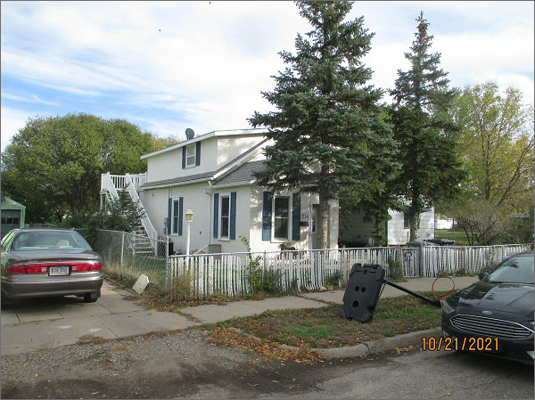
RECORD #4913

LOT SIZE 50’ X 140’ GROUND FLOOR 784 SQ FT
1 ½ STORY – SINGLE FAMILY TOTAL LIVING 1304 SQ FT
FAIR QUALITY & CONDITION 3 BEDROOMS 2 BATHS
BUILT IN 1937 BASEMENT 680 SQ FT
2014; STUCCO POOR 612 SQ FT FINISHED IN BASEMENT
ALUM. WINDOWS VINYL TRIM DETACHED GARAGE 468 SQ FT
NATURAL GAS – CENTRAL AIR CARPORT 198 SQ FT
SOLD ON 9/2/21 FOR $45,000
ASSESSED IN 2021 AT $49,130
SOLD ON 9/11/13 FOR $45,000
ASSESSED IN 2015 AT $49,130 RECORD #4913

