$130,000.00
HAFEY – BELGARDE/CAJAMARCA
510 CRESCENT ST. MOBRIDGE
MOBRIDGE BEL AIRE 1ST ADDN. LOT 3 BLOCK 5
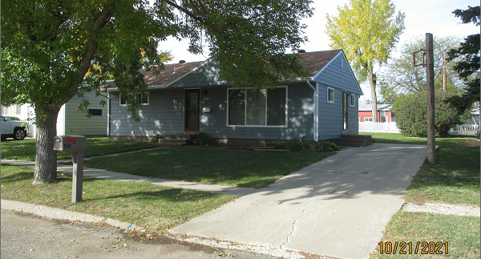
RECORD #4719

LOT SIZE 60’ X 130’ GROUND FLOOR 1128 SQ FT
SINGLE FAMILY – 1 STORY 3 BEDROOMS 1 ½ BATHS
AVERAGE QUALITY & CONDITION 864 SQ FT FINISHED BSMT.
BUILT IN 1965 ROOFED PORCH 168 SQ FT
2015; KITCHEN REMODEL $20,000 WOOD DECK 144 SQ FT
2008; REMODEL BASEMENT $10,600
2015; ROOF GOOD, VINYL SIDING
CENTRAL AIR – NATURAL GAS
SOLD ON 9/28/21 FOR $130,000
ASSESSED IN 2021 AT $106,810
SOLD ON 9/5/06 FOR $52,000
ASSESSED IN 2015 AT $75,875 RECORD #4719

