$125,000.00
BAUN – WHILE
106 17TH AVE EAST, MOBRIDGE
W 432’ OF S 243’ OF OUTLOT F & W 432’ OF OUTLOT G EXC. HWY IN EAST MOBRIDGE ADDN NE4 29-124-79
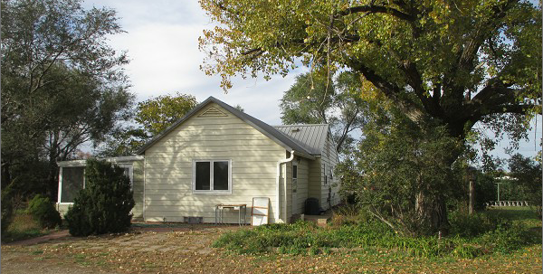
RECORD #3770

5.11 ACRES MAIN LIVING AREA 1288 SQ FT
SINGLE FAMILY – 1 STORY 3 BEDROOMS
FAIR CONDITION & QUALITY GARAGE/SHOP 960 SQ FT
BUILT IN 1930
SOLD ON 9/2/21 FOR $125,000
ASSESSED IN 2021 AT $58,305
SOLD ON 7/13/21 FOR $40,000
ASSESSED IN 2016 AT $58,305 RECORD #3770

