$240,000.00
ZIMMERMAN – ROESLER
310 20TH ST WEST, MOBRIDGE
LOT 1 OF SW4SE4 18-124-79
RECORD #3497

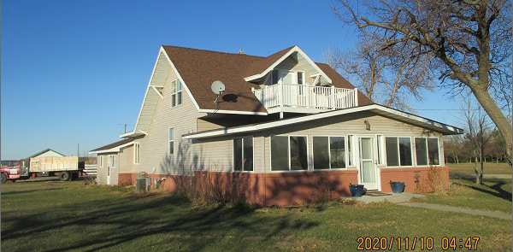
LOT SIZE 6 ACRES GROUND FLOOR 1176 SQ FT
SINGLE FAMILY – 1 ½ STORY TOTAL LIVING 1652 SQ FT
BELOW NORMAL CONDITION ATTACHED GARAGE 576 SQ FT
AVERAGE QUALITY 4 BEDROOMS
BUILT IN 1920 BASEMENT 952 SQ FT
2015; ROOF GOOD, BRICK FACE 80’ X 33’ METAL BUILDING
VINYL SIDING, WOOD DECK EAST POOR
WINDOWS POOR, SOME NEW 40’ X 24’ METAL SHED
CENTRAL AIR – NATURAL GAS 29’ X 29’ METAL SHED
SOLD ON 8/7/20 FOR $240,000 28’ X 16’ 3 SEASON PORCH
ASSESSED IN 2020 AT $94,200
ASSESSED IN 2013 AT $82,325 RECORD #3497

