$115,000.00
MERLKEL BROTHERS LLC – NELSON
415 9TH ST. WEST, MOBRIDGE
MOBRIDGE NWTS CO’ 1ST ADDN LOT 1A & UNDIVIDED 1/8 INT. LOT 9 REPLAT OF LOT 16, N 34’ LOT 15, LOT 9 & S 34’ OF LOT 10
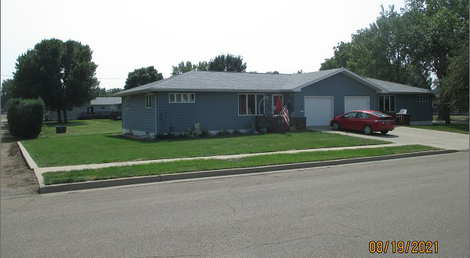
RECORD #7423

LOT SIZE 68.98’ X 64’ GROUND FLOOR 988 SQ FT
1 STORY DUPLEX BASEMENT 988 SQ FT
SINGLE FAMILY TOWNHOUSE 2 BEDROOMS ABOVE
BUILT IN 1994 1 BEDROOM IN BASEMENT
AVERAGE QUALITY & CONDITION 2 ½ BATHS
CENTRAL AIR – NATURAL GAS WOOD DECK 140 SQ FT
2014; CEMENT BOARD SIDING ATT. GARAGE 308 SQ FT
WINDOWS GOOD
SOLD ON 8/3/21 FOR $115,000 RECORD #7423
ASSESSED IN 2021 AT $101,780
SOLD ON 4/5/07 FOR $70,000 ASSESSED IN 2015 AT $99,680

