$362,500.00
THORSTENSON – CARLSON
1310 3RD AVE WEST, MOBRIDGE
MOBRIDGE THOMPSON’S OUTLOTS LOT 24
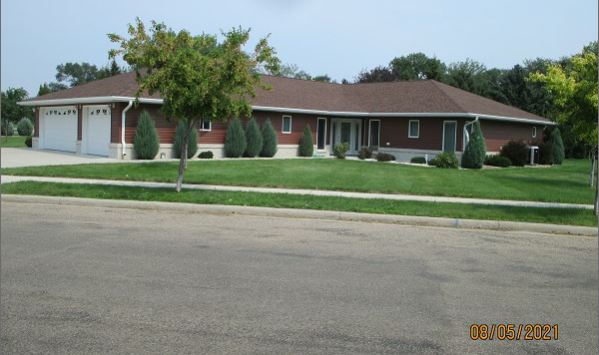
RECORD #6513

LOT SIZE 165’ X 264’ GROUND FLOOR 4308 SQ FT
SINGLE FAMILY – 1 STORY 3 SEASON PORCH 330 SQ FT
AVERAGE QUALITY & CONDITION ATTACHED GARAGE 992 SQ FT
BUILT IN 2014
SOLD ON 7/13/21 FOR $362,500
ASSESSED IN 2021 AT $324,530
ASSESSED IN 2017 AT $307,875 RECORD #6513

