$365,000.00
KONOLD – GUENTZEL
1918 KENNEDY DR. MOBRIDGE
MOBRIDGE SHOR ACRES LOT 94
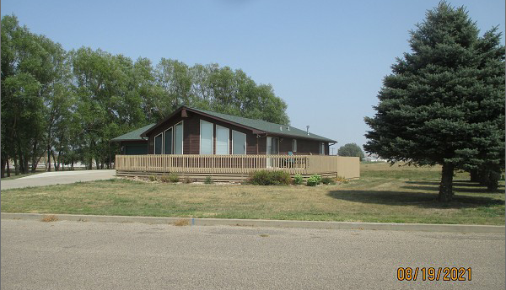
RECORD #6409

LOT SIZE 142.5’ X 120’ GROUND FLOOR 1405 SQ FT
SINGLE FAMILY – 1 STORY FINISHED BSMT 1325 SQ FT
AVERAGE QUALITY & CONDITION ATT. GARAGE 744 SQ FT
BUILT IN 2001 WOOD DECK 536 SQ FT
CENTRAL AIR, WOOD SIDING, 2 EGRESS 2 ½ BATHS
WOOD DECK, SLIDING GLASS DOOR 2 BEDROOMS ABOVE
SOLD ON 7/15/21 FOR $365,000 2 BEDROOMS BELOW
ASSESSED IN 2021 AT $238,930 GARAGE IS DRIVE THRU
SOLD ON 2/6/19 FOR $255,000 CLEANING SINK IN GARAGE
ASSESSED IN 2019 AT $232,680
SOLD ON 8/11/16 FOR $205,000 RECORD #6409

