$75,000.00
SCHATZ – SANDLAND
309 MAIN ST. MOBRIDGE
MOBRIDGE ORIGINAL LOTS 8 & 9 BLOCK 3
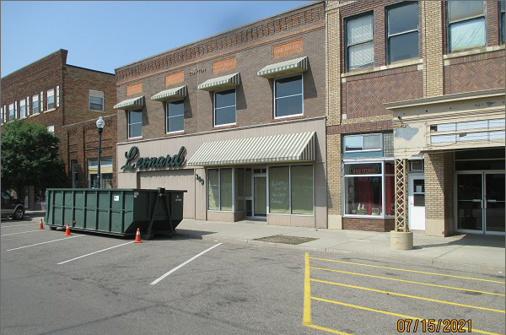
RECORD #6247

LOT SIZE 50’ X 140’ 2 STORY WITH BASEMENT
100% RETAIL STORE GROUND FLOOR 7,000 SQ FT
AVERAGE QUALITY & CONDITION BASEMENT 7000 SQ FT
BUILT IN 1920 + - 5,500 SQ FT FINISHED IN BSMT.
SOLD ON 6/22/2021 FOR $75,000 2ND FLOOR 7000 SQ FT STORAGE
ASSESSED IN 2021 AT $133,020 HVAC HEATING
ASSESSED IN 2015 AT $133,020

RECORD #6247

