$35,000.00
BENNETT – ROEBUCK/NISBET
114 3RD ST EAST, MOBRIDGE
MOBRIDGE ORIGINAL PLAT LOT 6A BLOCK 2
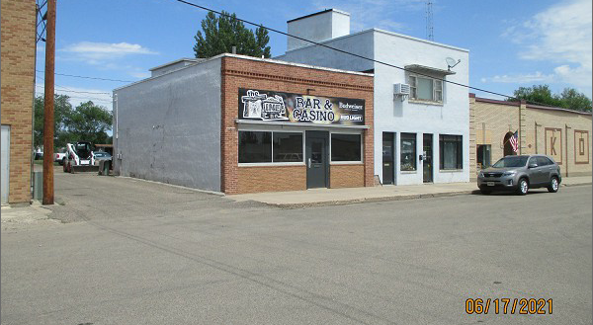
RECORD #6233

LOT SIZE 25’ X 50’
100 % COMMERCIAL BUILDING
BUILT IN 1910
ONE STORY
BUILDING 25’ X 40’
MASONRY BEARING WALLS
1 RESTROOM
SOLD ON 11/20/20 FOR $35,000
ASSESSED IN 2021 AT $20,000
SOLD ON 12/22/2011 FOR $20,000
ASSESSED IN 2011 AT $24,280 RECORD #6233

