$27,000.00
LINDSKOV – HARD ROCK INDUSTRIES
2 4TH AVENUE EAST, MOBRIDGE
MOBRIDGE NWTS EASTSIDE ADDN S 10’ OF LOTS 2 & 11 & ALL LOTS 3 THRU 9 & 12 THRU 22 BLOCK 1
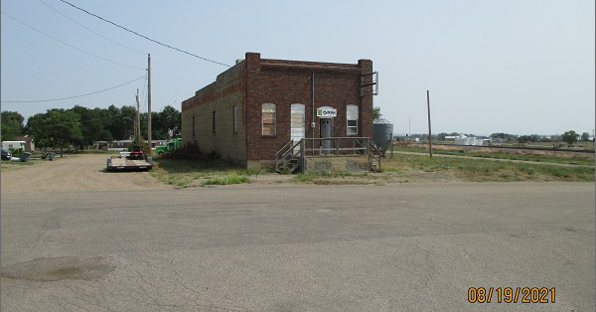
RECORD #6212

LOT SIZE 1.27 ACRES TOTAL FLOOR AREA 2000 SQ FT
100% STORAGE WAREHOUSE MASONARY BEARING WALLS
BUILT IN 1950 BASEMENT 2000 SQ FT
ONE STORY – BADLY WORN
REINFORCED CONCRETE FRAME
THICK WALLED BASEMENT
SOLD ON 7/21/2021 FOR $27,000
ASSESSED IN 2021 AT $31,865
ASSESSED IN 2015 AT $31,865 RECORD #6212

