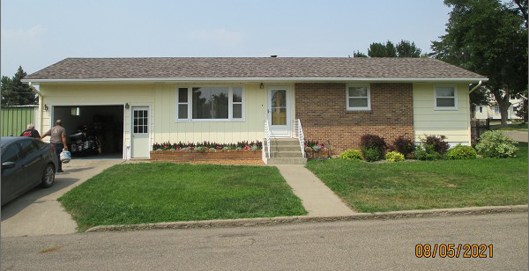
$150,000.00
SCHNEIDER – GOEHRING
810 7TH ST. WEST, MOBRIDGE
MOBRIDGE NWTS CO’S 3RD ADDN LOT 6 BLOCK 34
RECORD #6168

LOT SIZE 50’ X 140’ GROUND FLOOR 984 SQ FT
SINGLE FAMILY – 1 STORY BASEMENT 984 SQ FT
AVERAGE QUALITY & CONDITION 600 SQ FT FINISHED IN BSMT
BUILT IN 1967 2 BEDROOMS ABOVE 1 BELOW
2014; ROOF GOOD, MASONITE – GOOD 1 FULL BATH 2 HALF BATHS
BLOCK FOUNDATION, WINDOWS – FAIR ATTACHED GARAGE 360 SQ FT
CENTRAL AIR, SLAB PATIO REAR PATIO 264 SQ FT
SOLD ON 7/15/21 FOR $150,000
ASSESSED IN 2021 AT $105,600
ASSESSED IN 2016 AT $106,170 RECORD #6168

