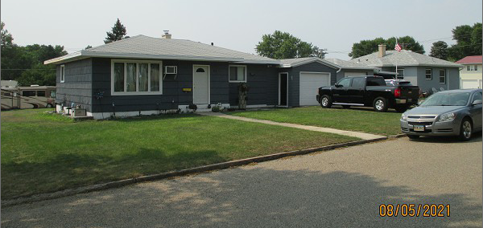
$65,000.00
PFITZER – SPIRY
719 7TH AVE WEST, MOBRIDGE
MOBRIDGE NWTS 3RD ADDN S ½ LOT 2 & ALL OF LOT 3 BLOCK 34
RECORD #6165

LOT SIZE 75’ X 140’ GROUND FLOOR 960 SQ FT
SINGLE FAMILY – 1 STORY 3 BEDROOMS
AVERAGE QUALITY & CONDITION 1 FULL BATH, 1 HALF BATH
BUILT IN 1956 ONE ¾ BATH
2014; WINDOW AIR, SLATE SIDING - FAIR
BLOCK FOUNDATION – GOOD BASEMENT 960 SQ FT
NATURAL GAS, WINDOWS – FAIR 240 SQ FT FIN REC IN BSMT
ATTACHED GARAGE MASONITE – POOR ATTACHED GARAGE 360 SQ FT
SOLD ON 7/8/21 FOR $65,000
ASSESSED IN 2021 AT $70,440
ASSESSED IN 2016 AT $68,710 RECORD #6165

