$178,000.00
BOSCH ESTATE – LETSCHE
912 7TH AVE WEST, MOBRIDGE
MOBRIDGE NWTS CO’S 2ND ADDN N 25’ OF LOT 9 & ALL LOT 10 BLOCK 6
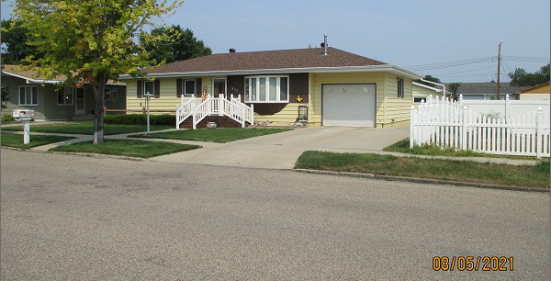
RECORD #6006

LOT SIZE 68’ X 140’ GROUND FLOOR 1066 SQ FT
SINGLE FAMILY – 1 STORY FULLY FURNISHED BASEMENT
AVERAGE QUALITY & CONDITION BASEMENT 1066 SQ FT
BUILT IN 1963 3 BEDROOMS ABOVE 1 BELOW
2014; ROOF GOOD, VINYL SIDING GOOD 1 FULL BATH, ONE ¾ BATH
WOOD DECK SLIDING GLASS ONE ½ BATH
WINDOWS GOOD, CENTRAL AIR ATTACHED GARAGE 288 SQ FT
POURED FDN – NEWER WINDOWS DETACHED GARAGE 552 SQ FT
SOLD ON 7/2/21 FOR $178,000 WOOD DECK 234 SQ FT
ASSESSED IN 2021 AT $133,650 EGRESS IN BASEMENT
ASSESSED IN 2014 AT $78,145 RECORD #6006

