$78,000.00
POURIER – SILVERNAGEL
910 5TH AVE. WEST, MOBRIDGE
MOBRIDGE NWTS 1ST ADDN LOT 8 BLOCK 8
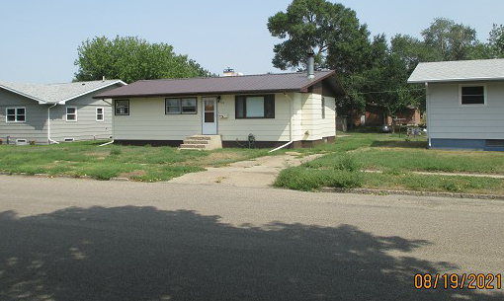
RECORD # 5948

LOT SIZE 140’ X 120’ GROUND FLOOR 1053 SQ FT
SINGLE FAMILY – 1 STORY BASEMENT 1053 SQ FT
AVERAGE QUALITY & CONDITION BASEMENT FINISHED
BUILT IN 1965 3 BEDROOMS ABOVE
2014; FIREPLACE, SIDING FAIR 1 BEDROOM BELOW
POURED FDN – SOME CRACKING 1 ½ BATHS
WINDOWS POOR, 2016; METAL ROOF CENTRAL AIR
SOLD ON 7/27/21 FOR $78,000 NATURAL GAS
ASSESSED IN 2021 AT $121,300
ASSESSED IN 2016 AT $115,750 RECORD #5948

