$145,000.00
LABRENSZ – RAUSCH
1021 4TH AVE WEST, MOBRIDGE
MOBRIDGE NWTS 1ST ADDN LOT 1 & N 22 ½ ‘ OF LOT 2 BLOCK 3
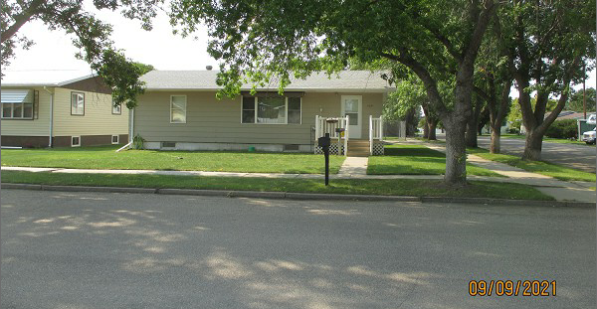
RECORD #5920

LOT SIZE 60’ X 140’ GROUND FLOOR 1120 SQ FT
SINGLE FAMILY – 1 STORY FINISHED BASEMENT 1120 SQ FT
AVERAGE QUALITY & CONDITION 2 BEDROOMS ABOVE 1 BELOW
BUILT IN 1973 1 FULL BATH, ONE ½ BATH
2014; SHINGLES FAIR, MASONITE SIDING ONE ¾ BATH
BLK. FDN. CRACKING, NATURAL GAS SOLID WALL PORCH 144 SQ FT
SOLD ON 7/28/21 FOR $145,000 ATTACHED GARAGE 672 SQ FT
ASSESSED IN 2021 AT $152,330
ASSESSED IN 2016 AT $149,560 RECORD #5920

