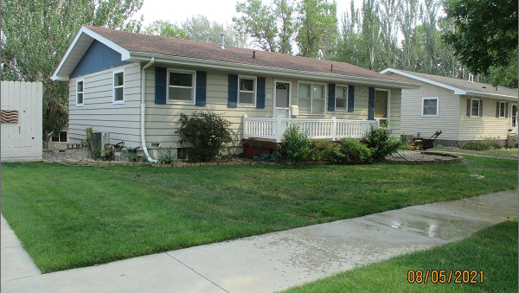
$146,000.00
RICHARDS – BLOCK/STANGL
1010 3RD AVE WEST, MOBRIDGE
MOBRIDGE NWTS 1ST ADDN N ½ OF LOT 13 ALL OF LOT 14 BLOCK 1
RECORD #5910

LOT SIZE 60’ X 140’ GROUND FLOOR 1092 SQ FT
SINGLE FAMILY – 1 STORY 4 BEDROOMS 1 FULL BATH
AVERAGE QUALITY & CONDITION ONE ¾ BATH, ONE ½ BATH
BUILT IN 1965 BASEMENT 780 SQ FT
2014; ROOF GOOD, WINDOWS GOOD BSMT WALKOUT FULL LIVING
POURED FDN, SIDING FAIR ATTACHED GARAGE 12’ X 26’
TUCK UNDER GARAGE TUCK UNDER GARAGE
SOLD ON 6/29/21 FOR $146,000 DETACHED GARAGE 28’ X 28’
ASSESSED IN 2021 AT $137,380 CENTRAL AIR
SOLD ON 2/5/18 FOR $137,900 WOOD BURNER
ASSESSED IN 2018 AT $134,610 8’ X 12’ LAWN SHED

RECORD #5910

