$48,000.00
OLSON – CONNER
118 3RD AVE. EAST, MOBRIDGE
MOBRIDGE-MILW LAND CO’S 2ND ADDN LOT 11 BLOCK 30
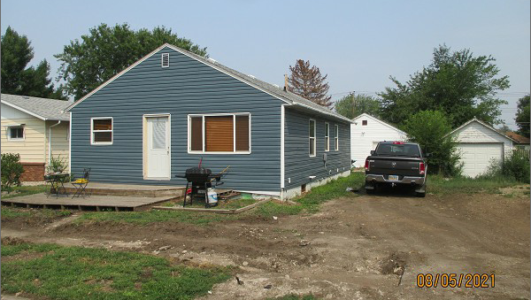
RECORD #5899

LOT SIZE 50’ X 140’ GROUND FLOOR 1040 SQ FT
SINGLE FAMILY – 1 STORY 2 BEDROOMS 2 FULL BATHS
AVERAGE QUALITY & CONDITION ONE ¾ BATH
BUILT IN 1940
2009; INSTALL 2 EGRESS
SOLD ON 7/14/21 FOR $48,000
ASSESSED IN 2021 AT $37,280
SOLD ON 7/11/14 FOR $55,000
ASSESSED IN 2013 AT $32,415

