$87,500.00
STREET – LORENZEN
1115 1ST AVE WEST, MOBRIDGE
MOBRIDGE MAIN PARK S 25’ LOT 5 & N 25’ LOT 6 BLOCK 24
RECORD #5723
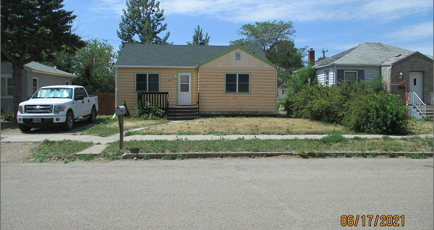
LOT SIZE 50’ X 142’ TOTAL LIVING AREA 843 SQ FT
SINGLE FAMILY – ONE STORY BASEMENT 843 SQ FT
FAIR QUALITY & CONDITION 2 BEDROOMS 1 ½ BATHS
BUILT IN 1950 DETACHED GARAGE 264 SQ FT
2014; MASONITE SIDING FAIR SOLID WALL PORCH 63 SQ FT
ALUMINUM WINDOWS FAIR
2013 NEW FURNACE
SOLD ON 5/26/21 FOR $87,500
ASSESSED IN 2021 AT $56,200
SOLD IN 2019 FOR $85,000
ASSESSED IN 2019 AT $20,900 RECORD #5723

