$235,000.00
JENSEN – SEAMAN
810 3RD AVE EAST, MOBRIDGE
MOBRIDGE MAIN PARK LOTS 11 & 12 BLOCK 4
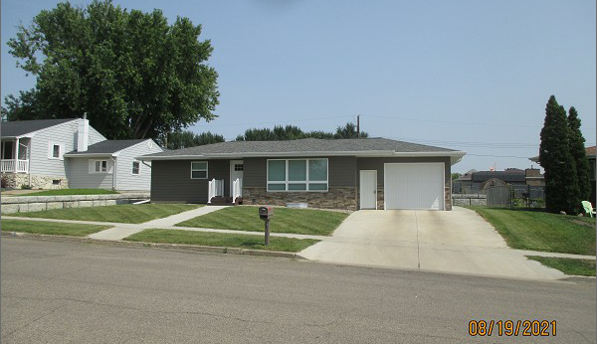
RECORD #5575

LOT SIZE 75’ X 142’ GROUND FLOOR 1120 SQ FT
SINGLE FAMILY – 1 STORY FINISHED BASEMENT
AVERAGE QUALITY & CONDITION 2 BEDROOMS ABOVE
BUIL IN 1960 1 BEDROOM BELOW
2014; CENTRAL AIR, NATURAL GAS 2 ½ BATHS
BLOCK BSMT, SLAB PATIO EAST ATT. GARAGE 384 SQ F
3’ RETAINER WALL NORTH & EAST LARGE DET. GARAGE
2021; SIDING, ROOFING, WINDOWS GOOD
SOLD ON 7/28/21 FOR $235,000
ASSESSED IN 2021 AT $147,480
ASSESSED IN 2018 AT $116,420 RECORD #5575

