$129,900.00
WEBSTER – HULM
203 4TH AVE WEST, MOBRIDGE
MOBRIDGE GRAND CROSSING OUTLOTS OUTLOT A
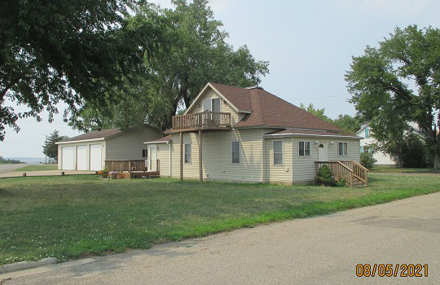
RECORD #5526

LOT SIZE 67’ X 140’ TOTAL LIVING 1288 SQ FT
SINGLE FAMILY - 1 STORY GROUND FLOOR 1032 SQ FT
AVERAGE QUALITY & CONDITION BASEMENT (DIRT) 728 SQ FT
BUILT IN 1907 2 BEDROOMS 1 ½ BATHS
LOTS OF REMODELING, CENTRAL AIR 10’ X 16’ SOLID WALL PORCH
SOLD ON 7/9/21 FOR $129,900 6’ X 12’ WOOD DECK
ASSESSED IN 2021 AT $92,650 30’ X 40’ DETACHED
SOLD ON 1/31/2017 FOR $120,000
ASSESSED IN 2017 AT $72,590 RECORD #5526

