$92,000.00
FAEHNRICH – BEZENEK
605 6TH AVE WEST, MOBRIDGE
MOBRIDGE GRAND CROSSING ADDN LOTS 5 & 6 BLOCK 51
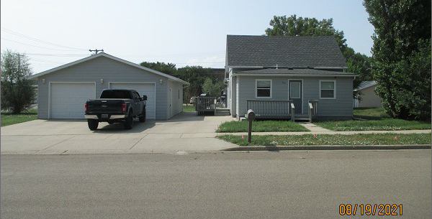
RECORD #5392

LOT SIZE 50’ X 140’ GROUND FLOOR 792 SQ FT
SINGLE FAMILY – 1 STORY 2 BEDROOMS 1 ½ BATHS
AVERAGE QUALITY & CONDITION SOLID WALL PORCH 176 SQ FT
BUILT IN 1920 WOOD DECK 96 SQ FT
2021; SIDING & ROOFING GOOD BASEMENT 648 SQ FT
SOLD ON 7/23/21 FOR $92,000 DETACHED GARAGE 1200 SQ F
ASSESSED IN 2021 AT $56,620 DETACHED GARAGE 308 SQ FT
SOLD ON 4/27/13 FOR $65,000
ASSESSED IN 2013 AT $20,150 RECORD #5392

