$85,000.00
BUESCHER – GIRTZ
5 7TH AVE EAST, MOBRIDGE
MOBRIDGE EKLO’S 3RD ADDN LOT 16A
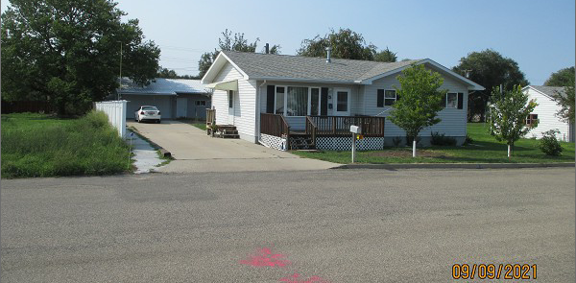
RECORD #5021

LOT SIZE 46 ½’ X 150’ TOTAL LIVING AREA 1080 SQ FT
SINGLE FAMILY – 1 STORY 2 BEDROOMS 1 ½ BATHS
AVERAGE QUALITY & CONDITION 24’ X 34’ DETACHED GARAGE
BUILT IN 2002 NATURAL GAS – CENTRAL AIR
SOLD ON 8/3/21 FOR $85,000
ASSESSED IN 2021 AT $67,180
SOLD ON 9/20/18 FOR $77,500 RECORD #5021
ASSESSED IN 2014 AT $58,260

