$150,000.00
FUHRER – SCHMEICHEL
606 12TH ST WEST, MOBRIDGE
MOBRIDGE BEL AIRE 2ND ADDN 2ND SUBDV LOT 25 BLOCK 2
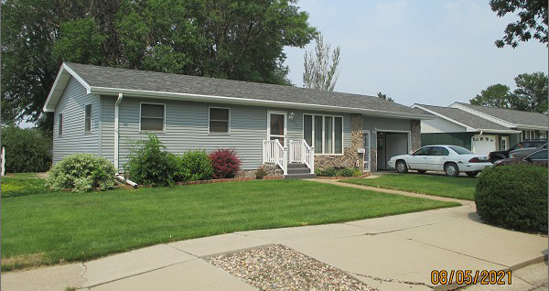
RECORD #4753

LOT SIZE 71’ X 130’ GROUND FLOOR 1040 SQ FT
SINGLE FAMILY – 1 STORY BASEMENT 1040 SQ FT
AVERAGE QUALITY & CONDITION 500 SQ FT FINISHED REC.
BUILIT IN 1960 3 BEDROOMS ABOVE
2014; ROOF GOOD, NO ALLEY ACCESS 1 BEDROOM BELOW
ALUM. SIDING, CENTRAL AIR 1 FULL BATH, ONE ¾ BATH
NATURAL GAS, WINDOWS GOOD ATT. GARAGE 442 SQ FT
BLOCK FOUNDATION WOOD DECK 200 SQ FT
SOLD ON 7/16/21 FOR $150,000 OPEN SLAB 200 SQ FT
ASSESSED IN 2020 AT $113,310 2004; NEW SIDING
ASSESSED IN 2017 AT $82,540 DET. GARAGE 480 SQ FT

